ImageJ Guide – Creating a ground truth from scratch for Mac OS

Navigate to ImageJ -> File -> Open

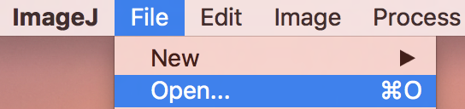

Select a PNG frame to draw the ground truth for

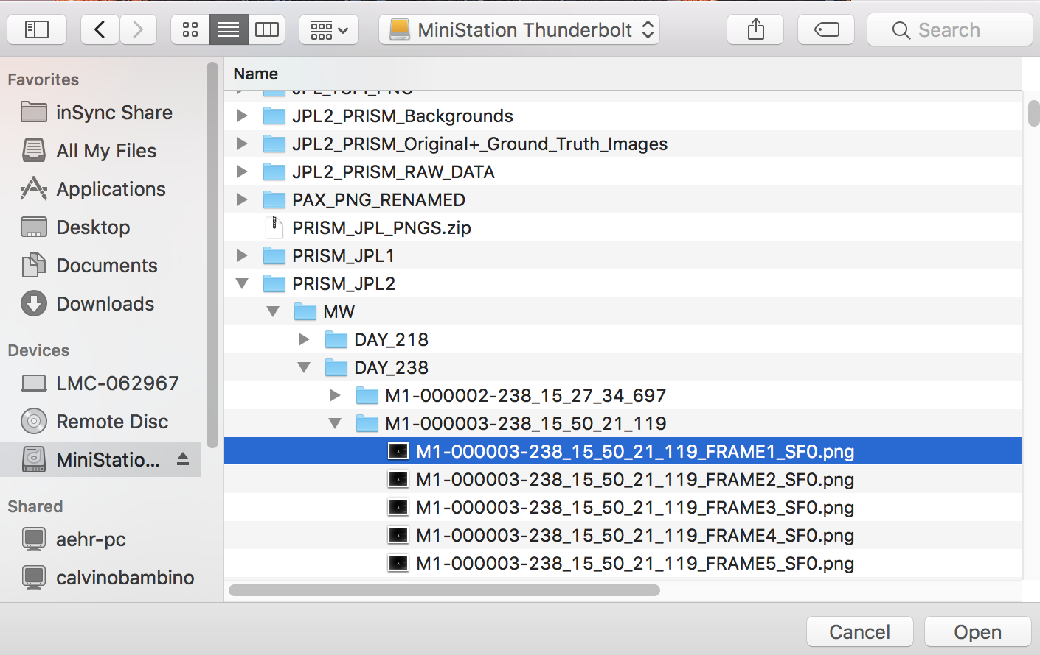

Navigate to ImageJ -> Image -> Zoom to magnify image (Zoom in as necessary) or CMD +

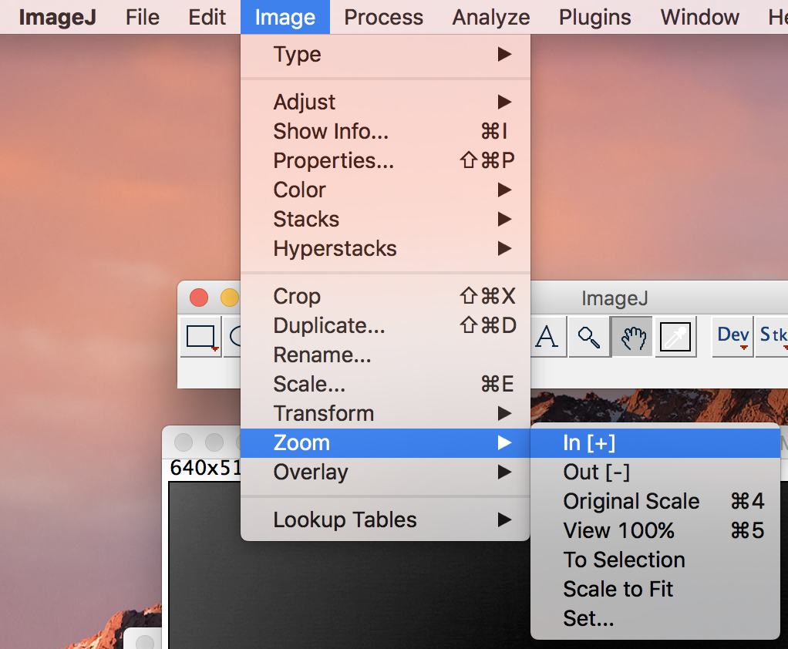

Navigate to the ImageJ Toolbar and select the Hand icon to drag the frame into the center

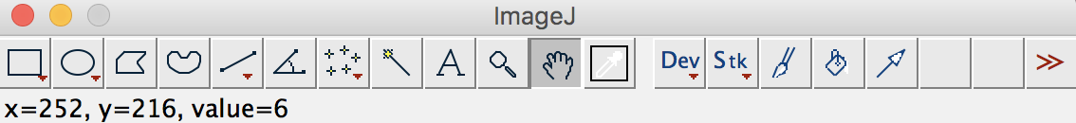

Navigate to ImageJ -> Analyze -> Tools -> ROI Manager

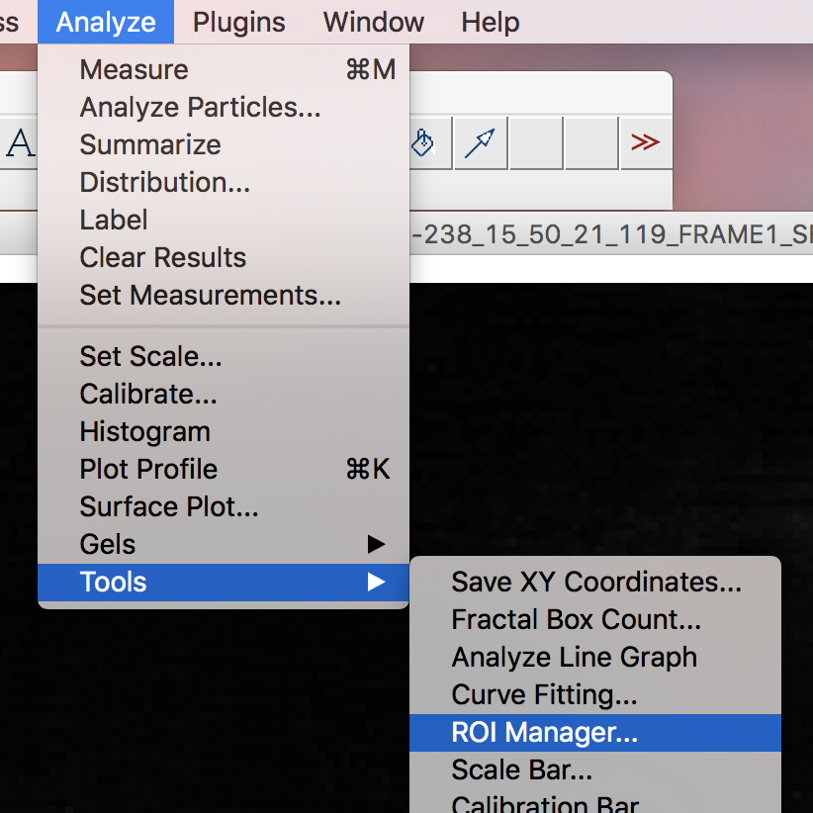

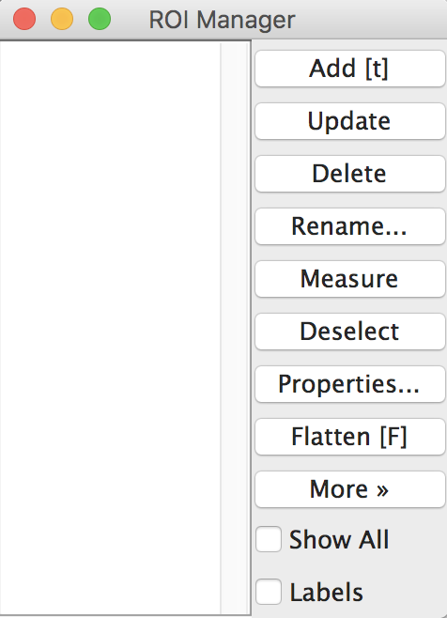

Navigate to ImageJ -> Image -> Adjust -> Threshold

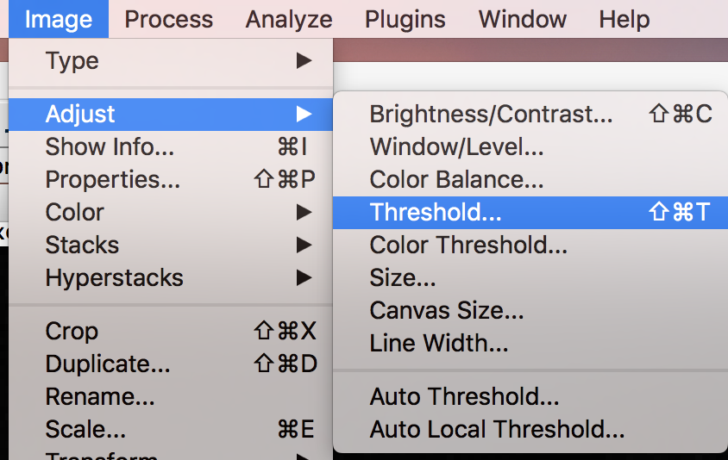

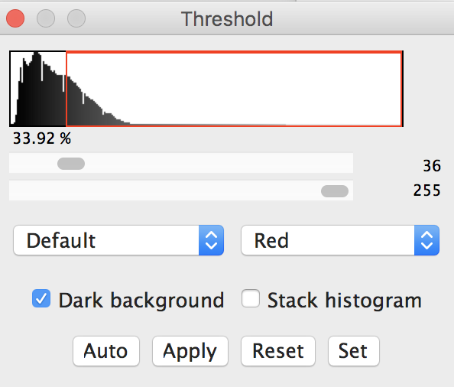

There are two methods to applying a threshold:

Thresholding for the target (highlighting target), or thresholding for the background (highlighting background)

To threshold for target: Select dark background, set bottom threshold slider to 255, and adjust top slider accordingly

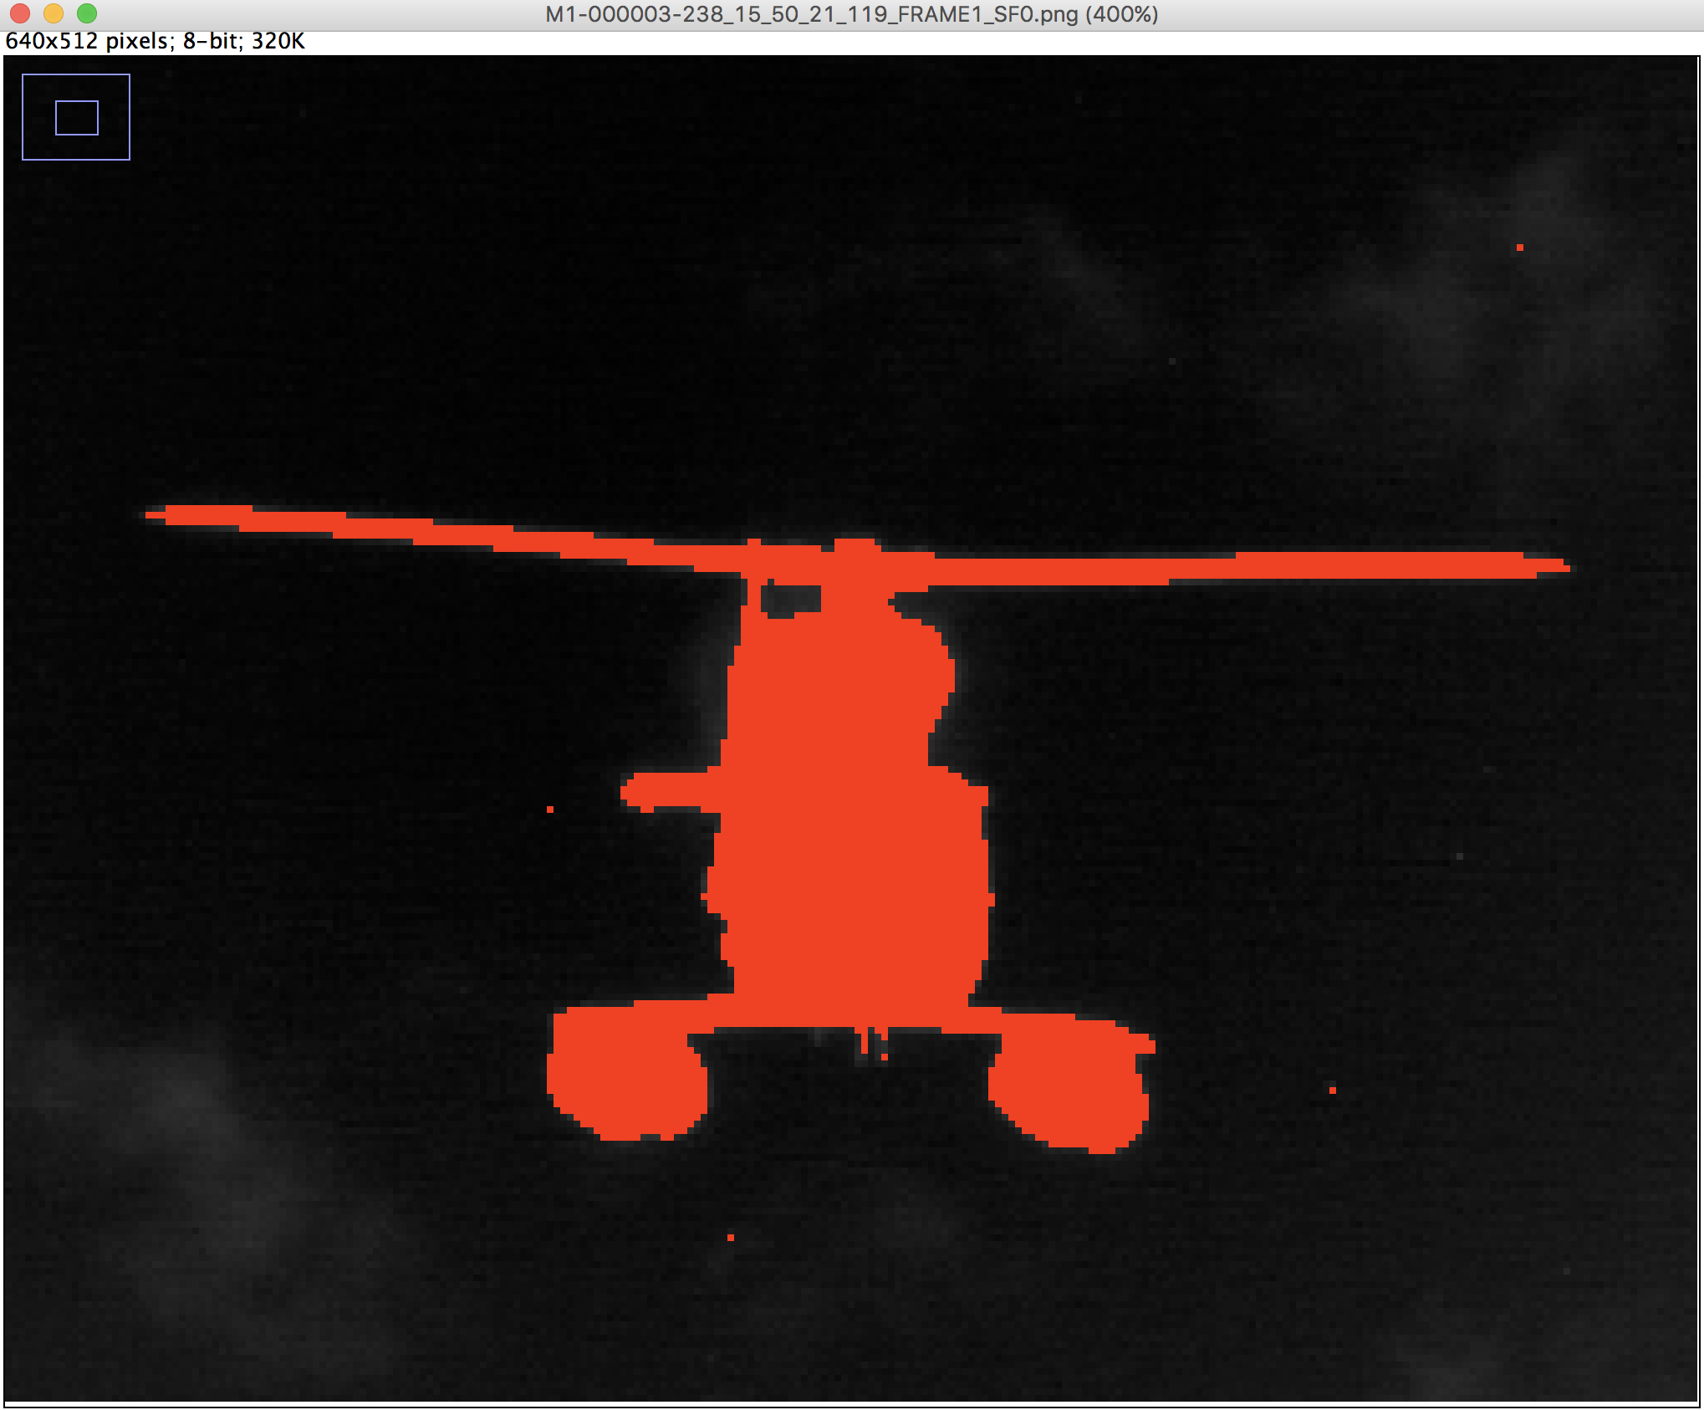

To threshold for background: Unselect dark background, set top slider to 0 and adjust bottom slider accordingly

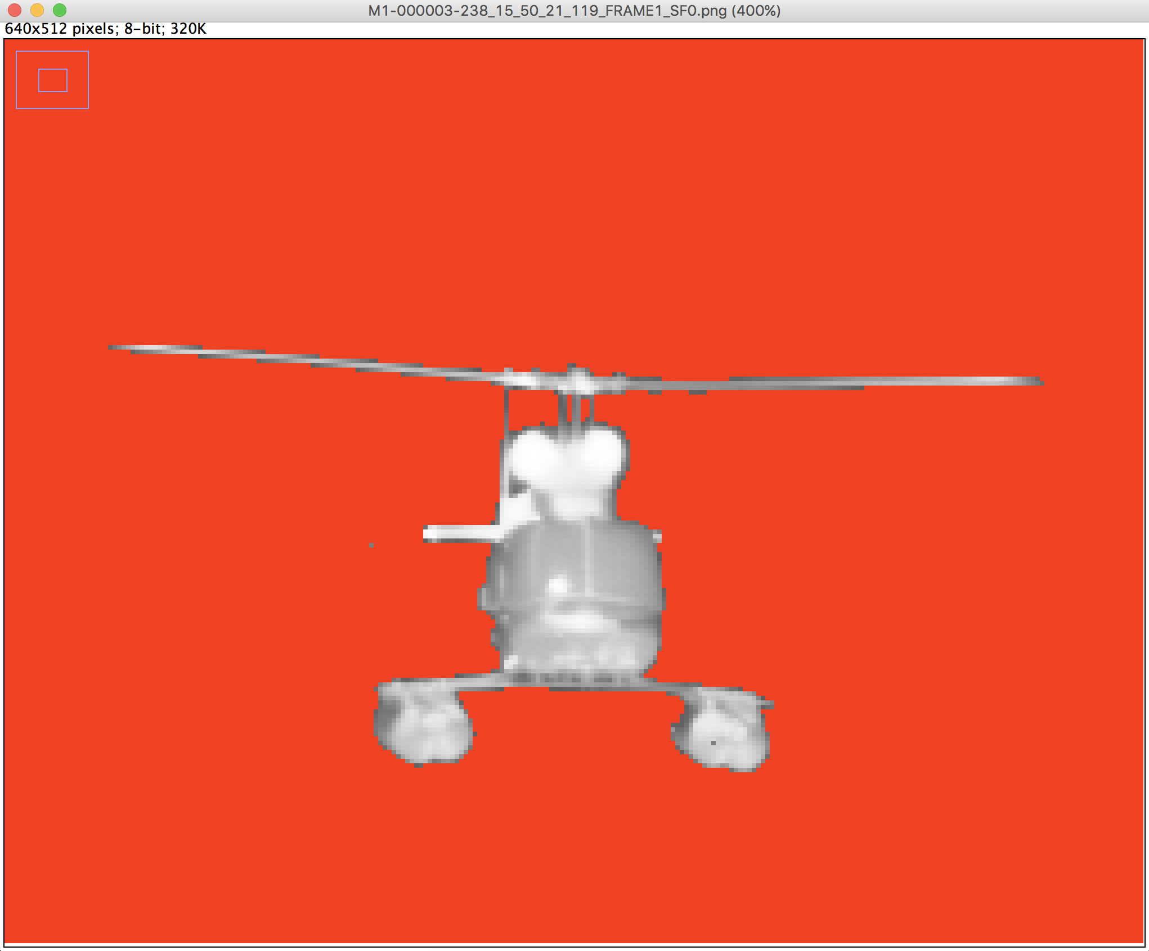

It is recommended to do both; threshold for target (include only target pixels), threshold for background (include only background pixels) and then use both masks to create a single mask.

Threshold for target then select Apply in threshold window

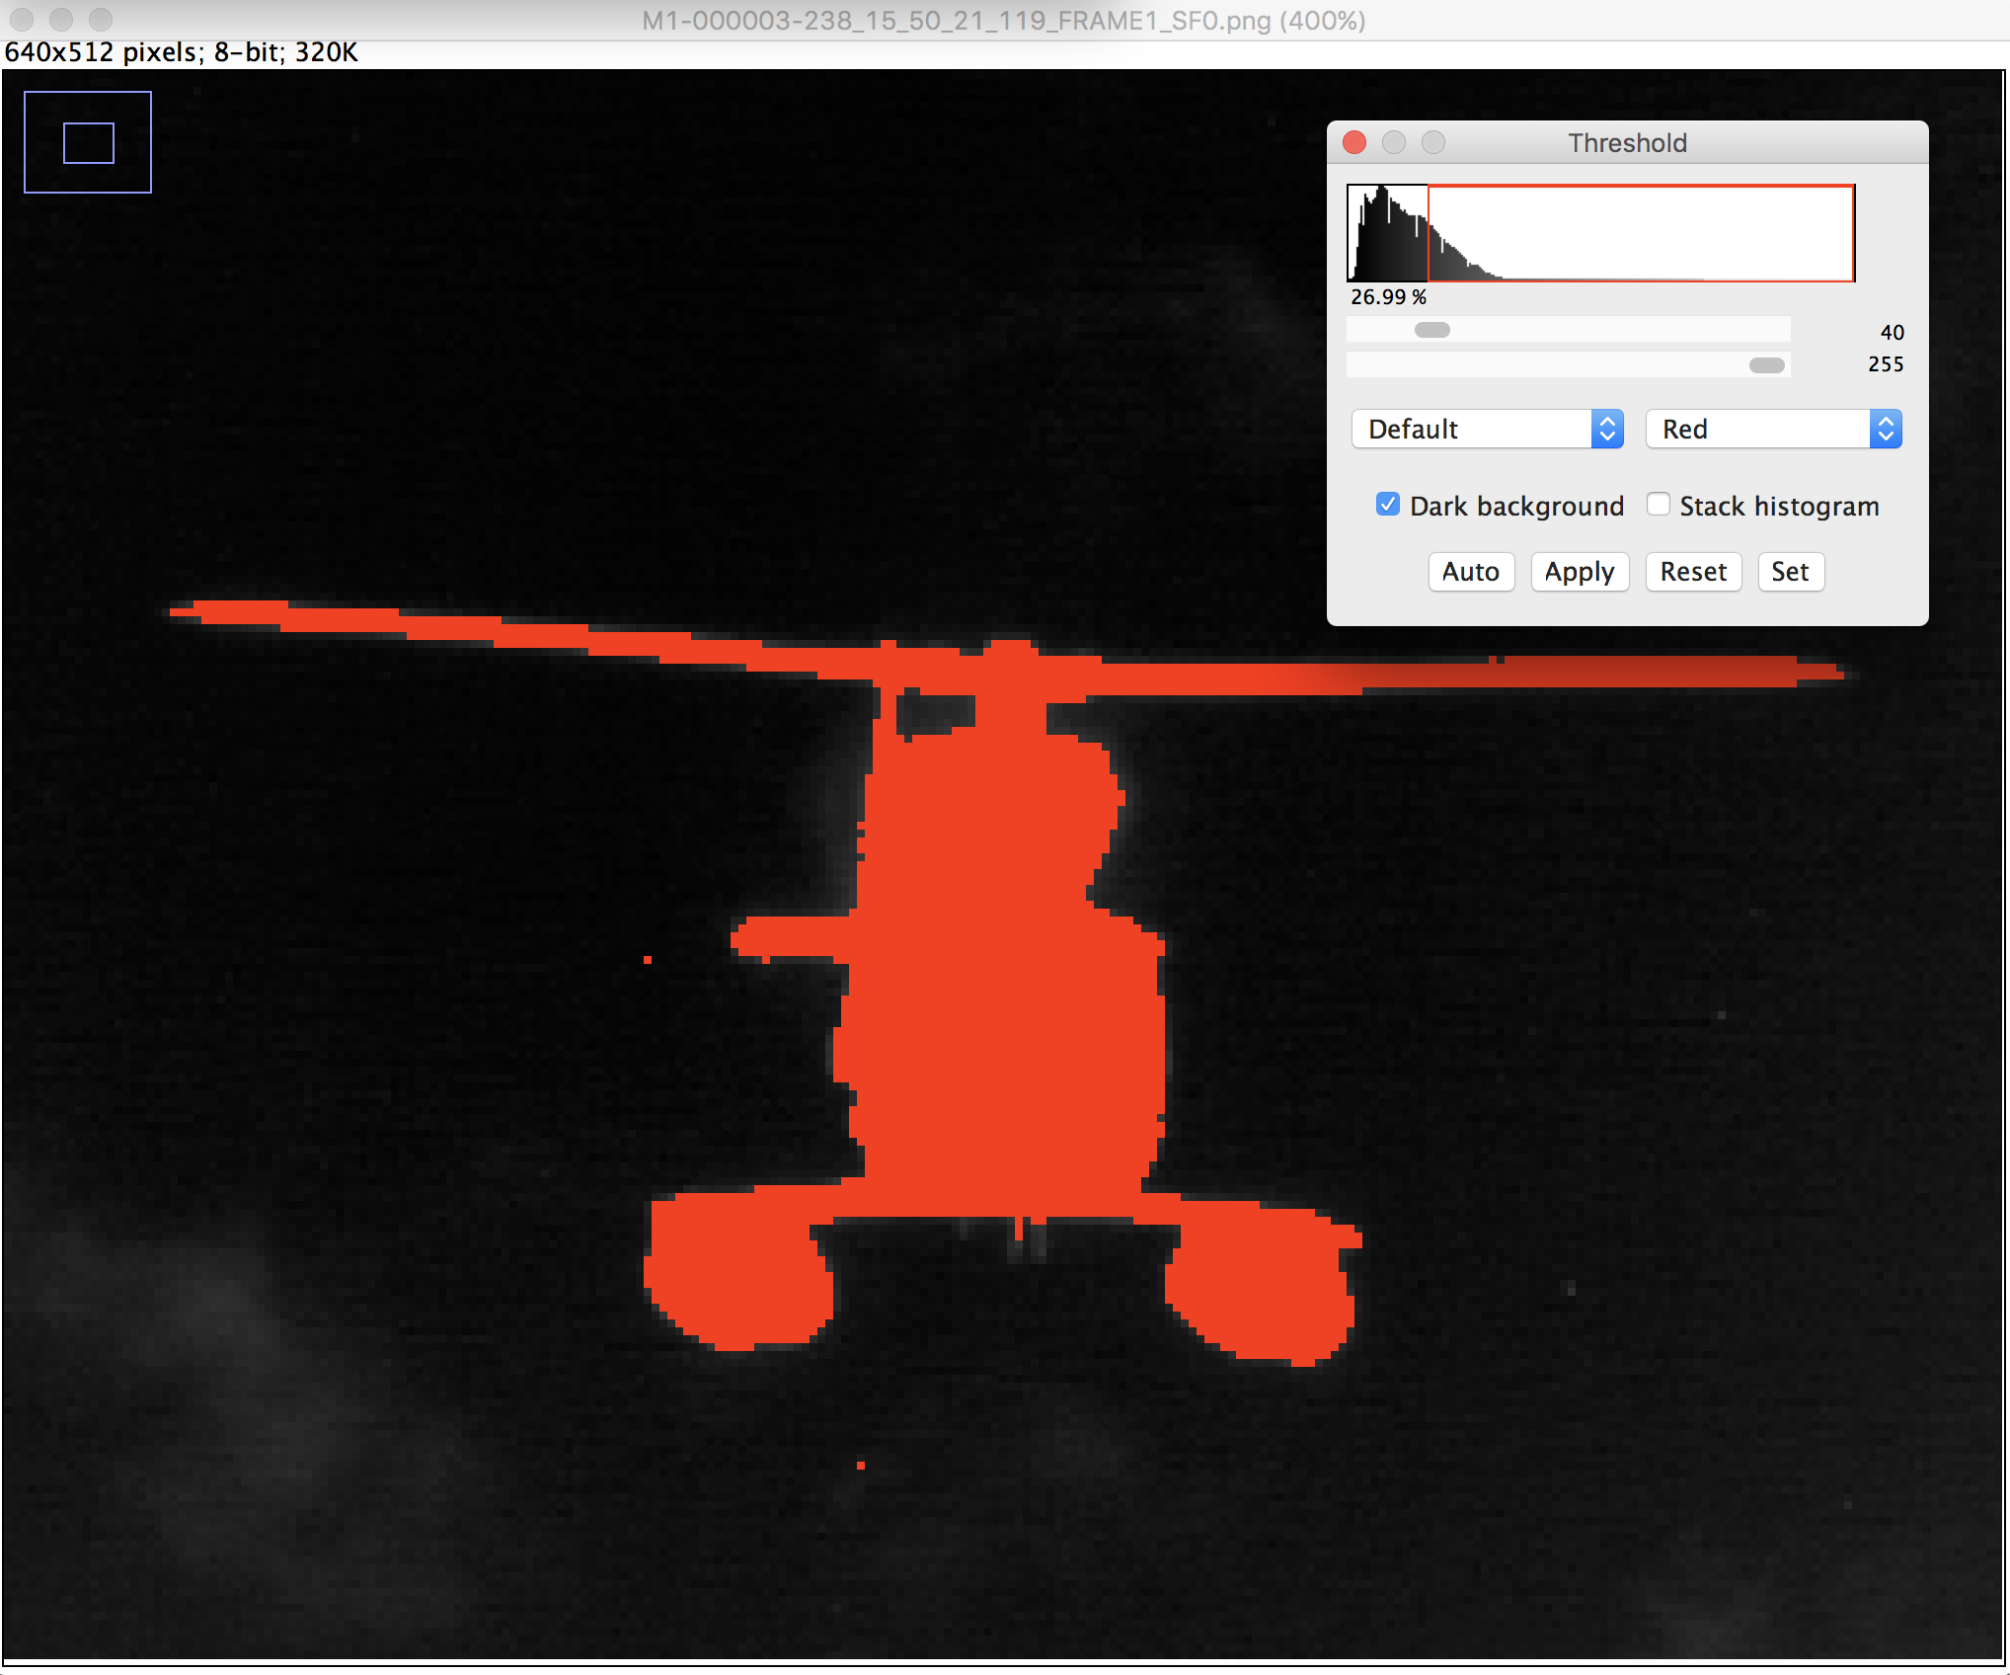

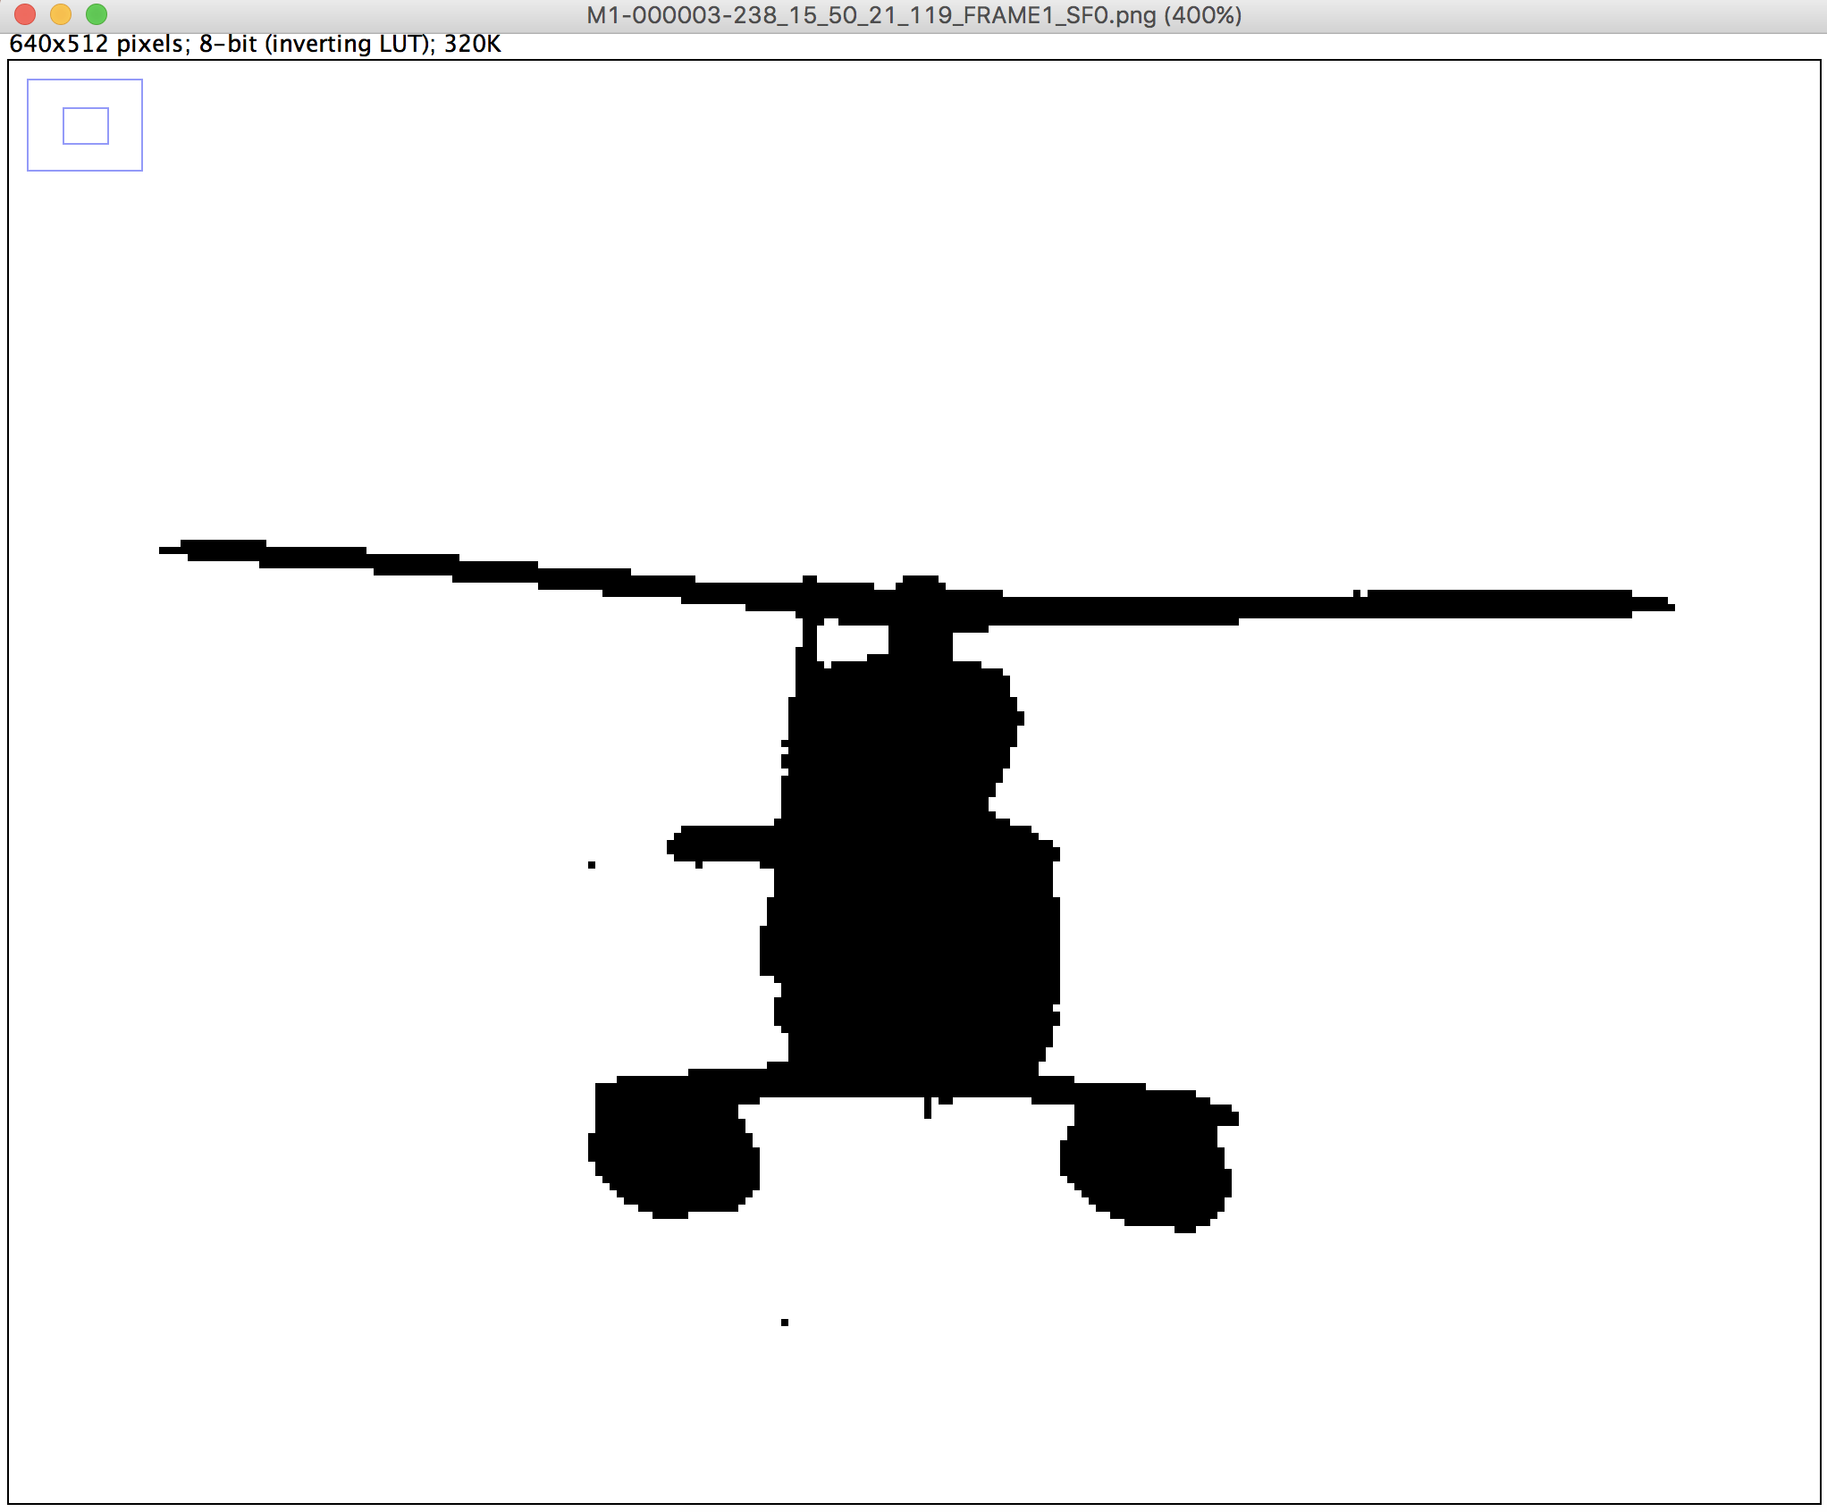

Navigate to Edit and select Invert

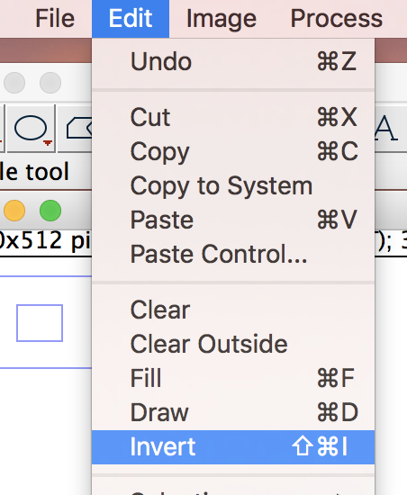

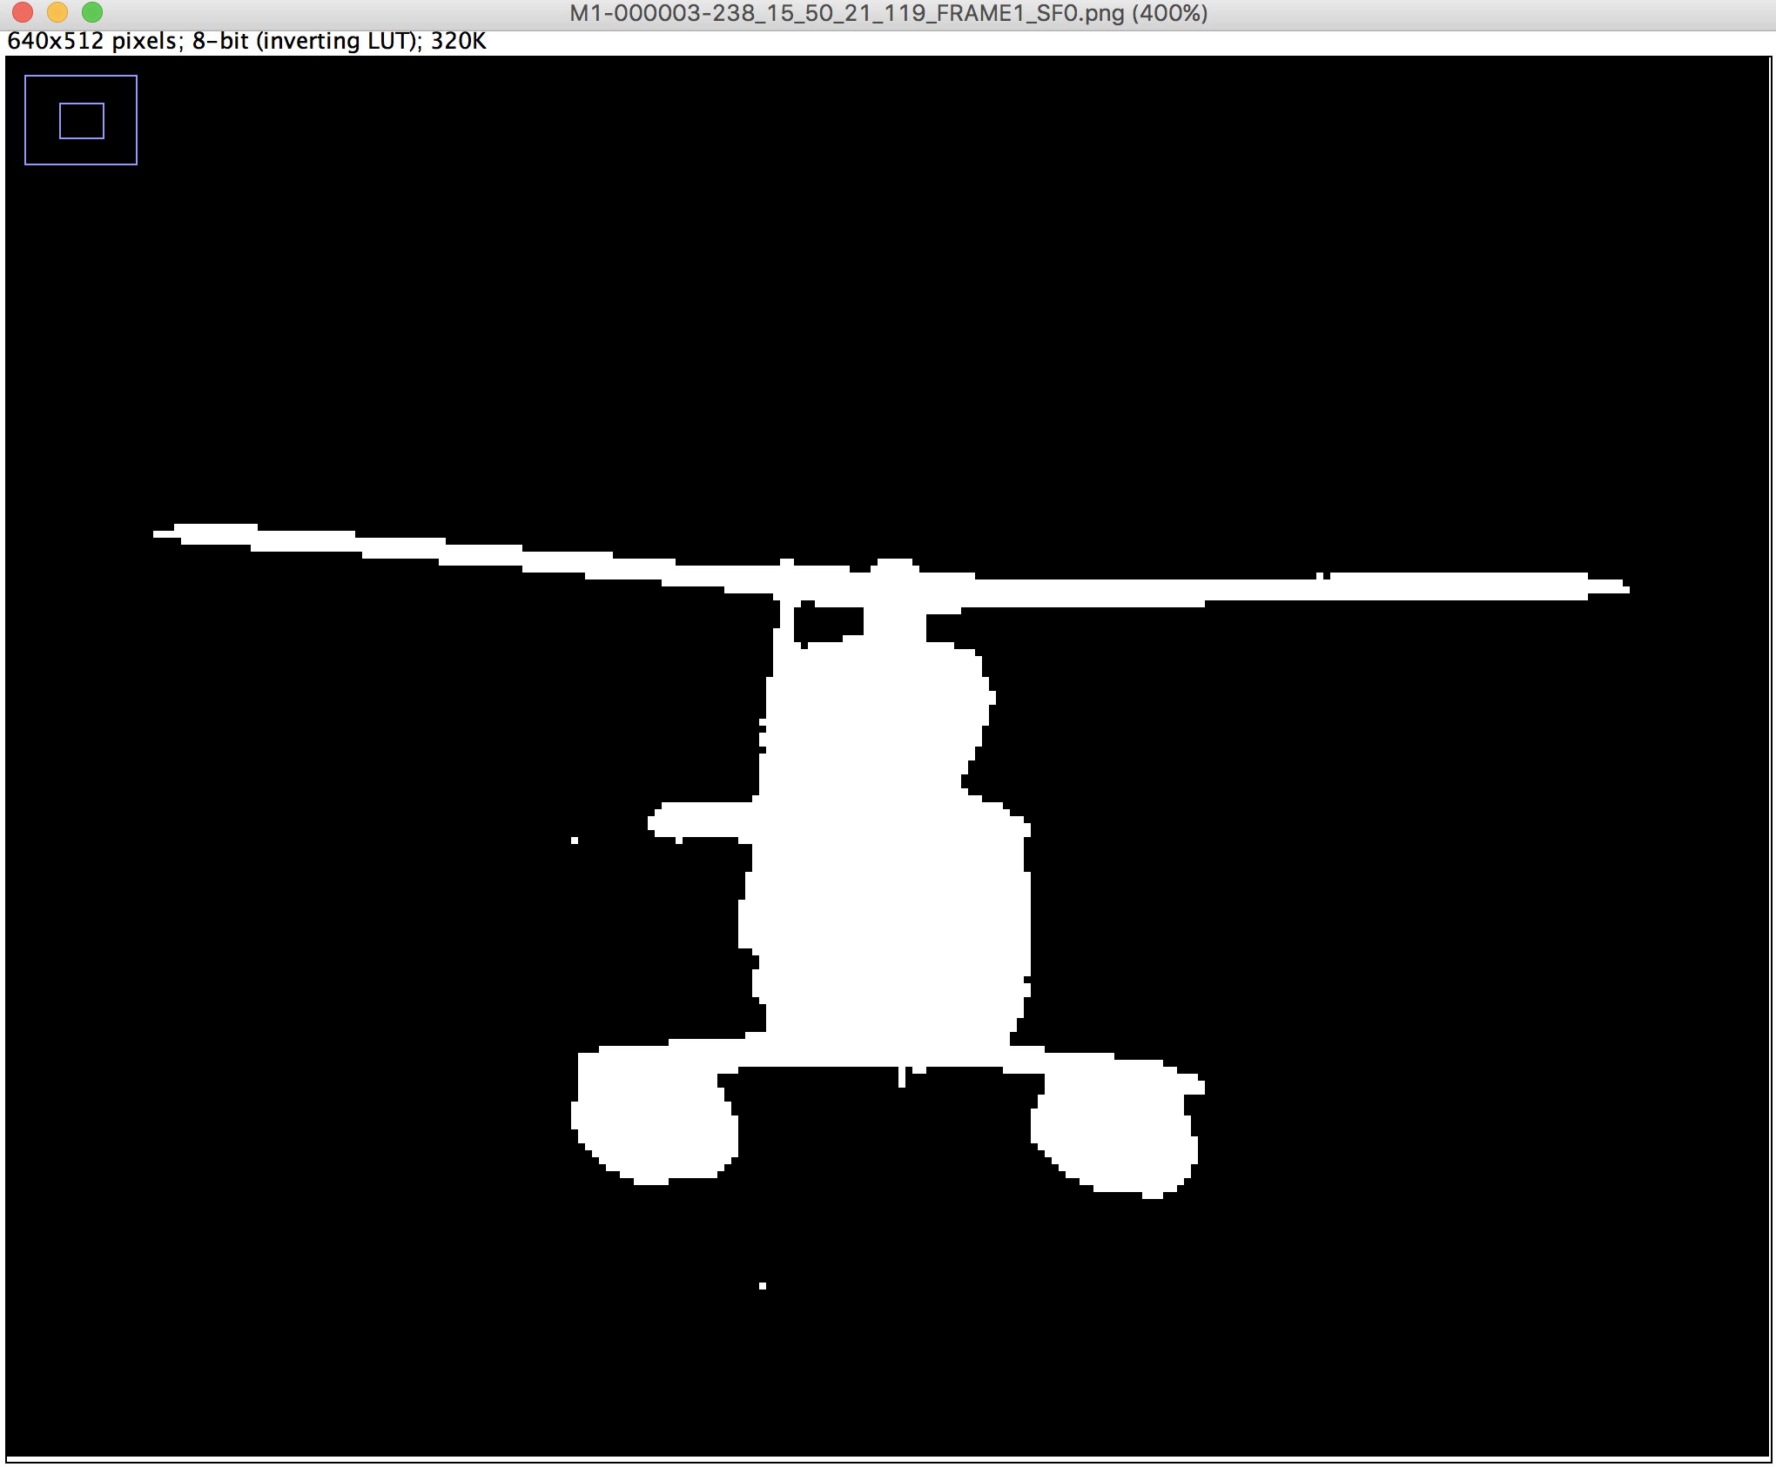

Select the Wand tracing tool and click on the target mask

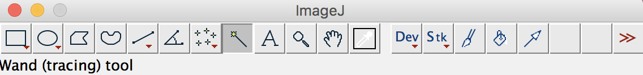

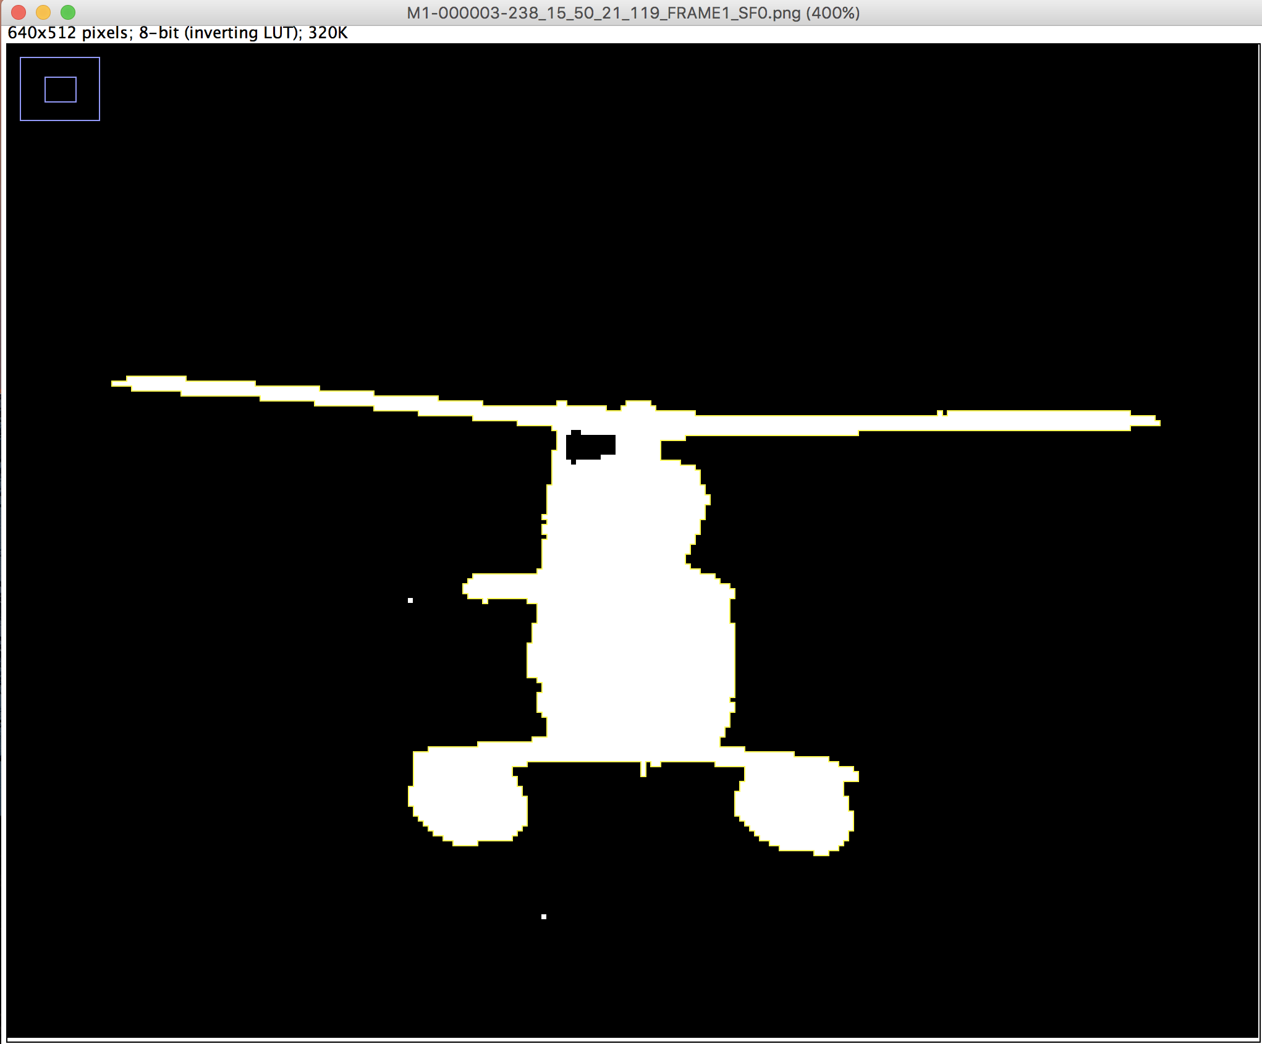

Navigate to the ROI Manager window and select Add, and rename to Target Mask

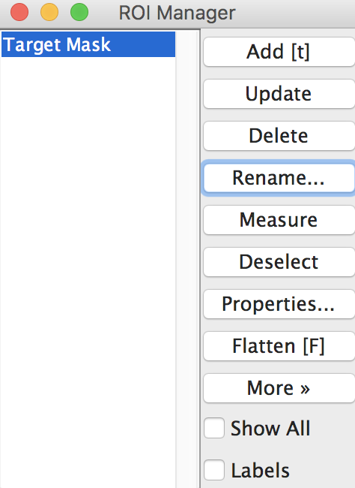

Close the image window – Do not save!

Navigate to File -> Open Recent and select the image previously loaded, then select ‘Target Mask’ in the ROI manager to highlight the outline on the original frame

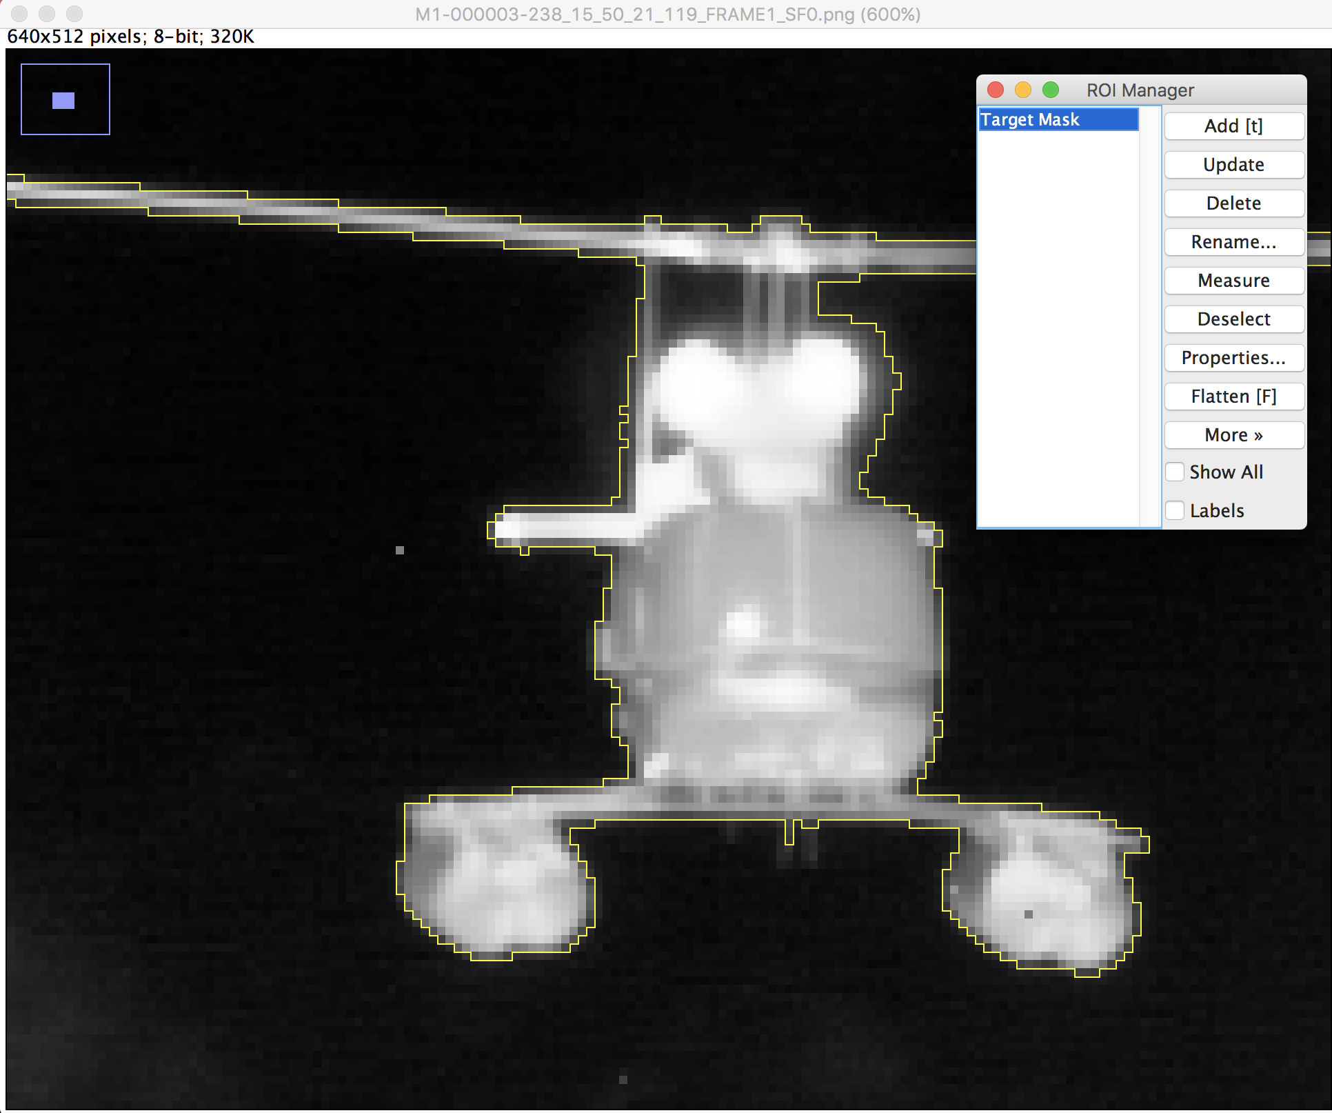

Choose an area to refine, in this case we are looking at the area between the rotor spokes and the left tail. Navigate to Edit -> Selection -> Select None

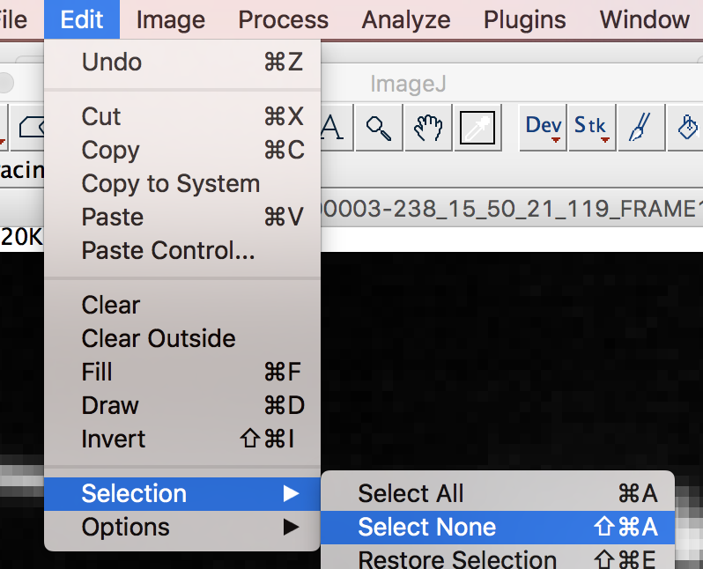

Choose a drawing tool (Rectangle, Circle, Polygon or Freehand) to mark the area to apply the threshold

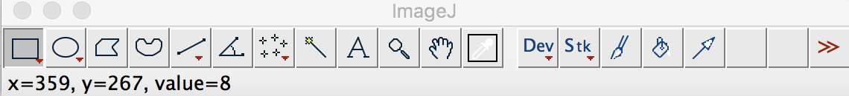

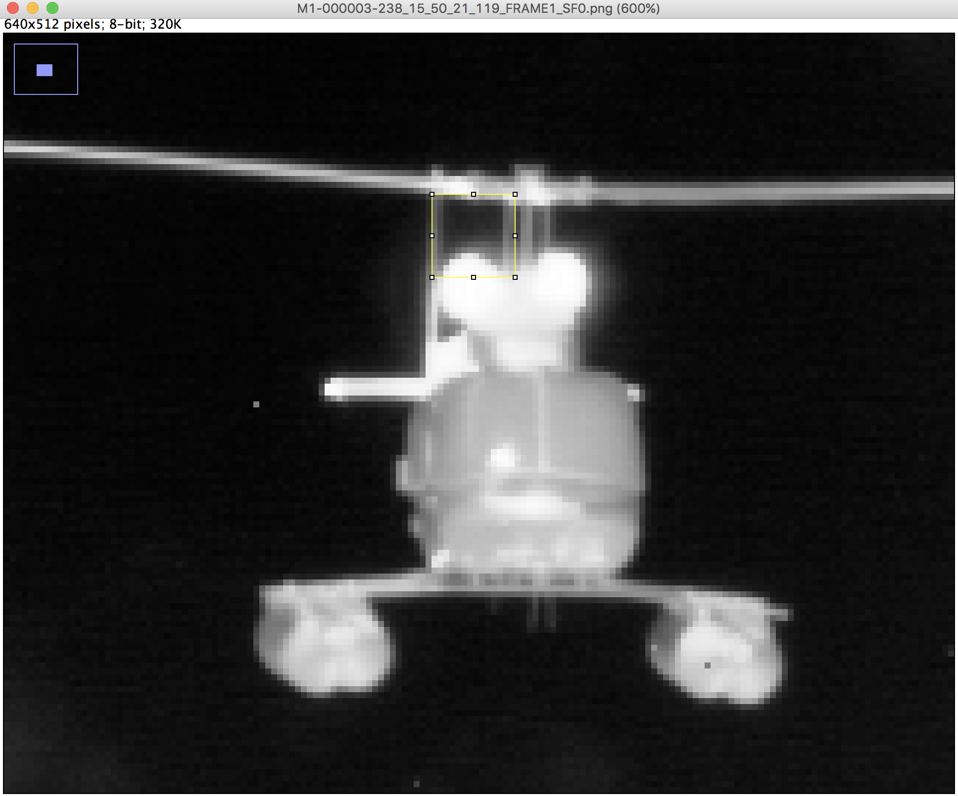

Navigate to Edit -> Clear Outside

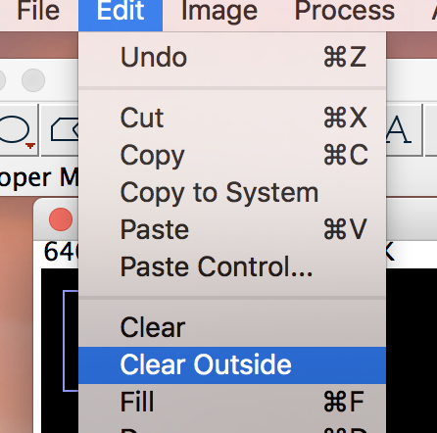

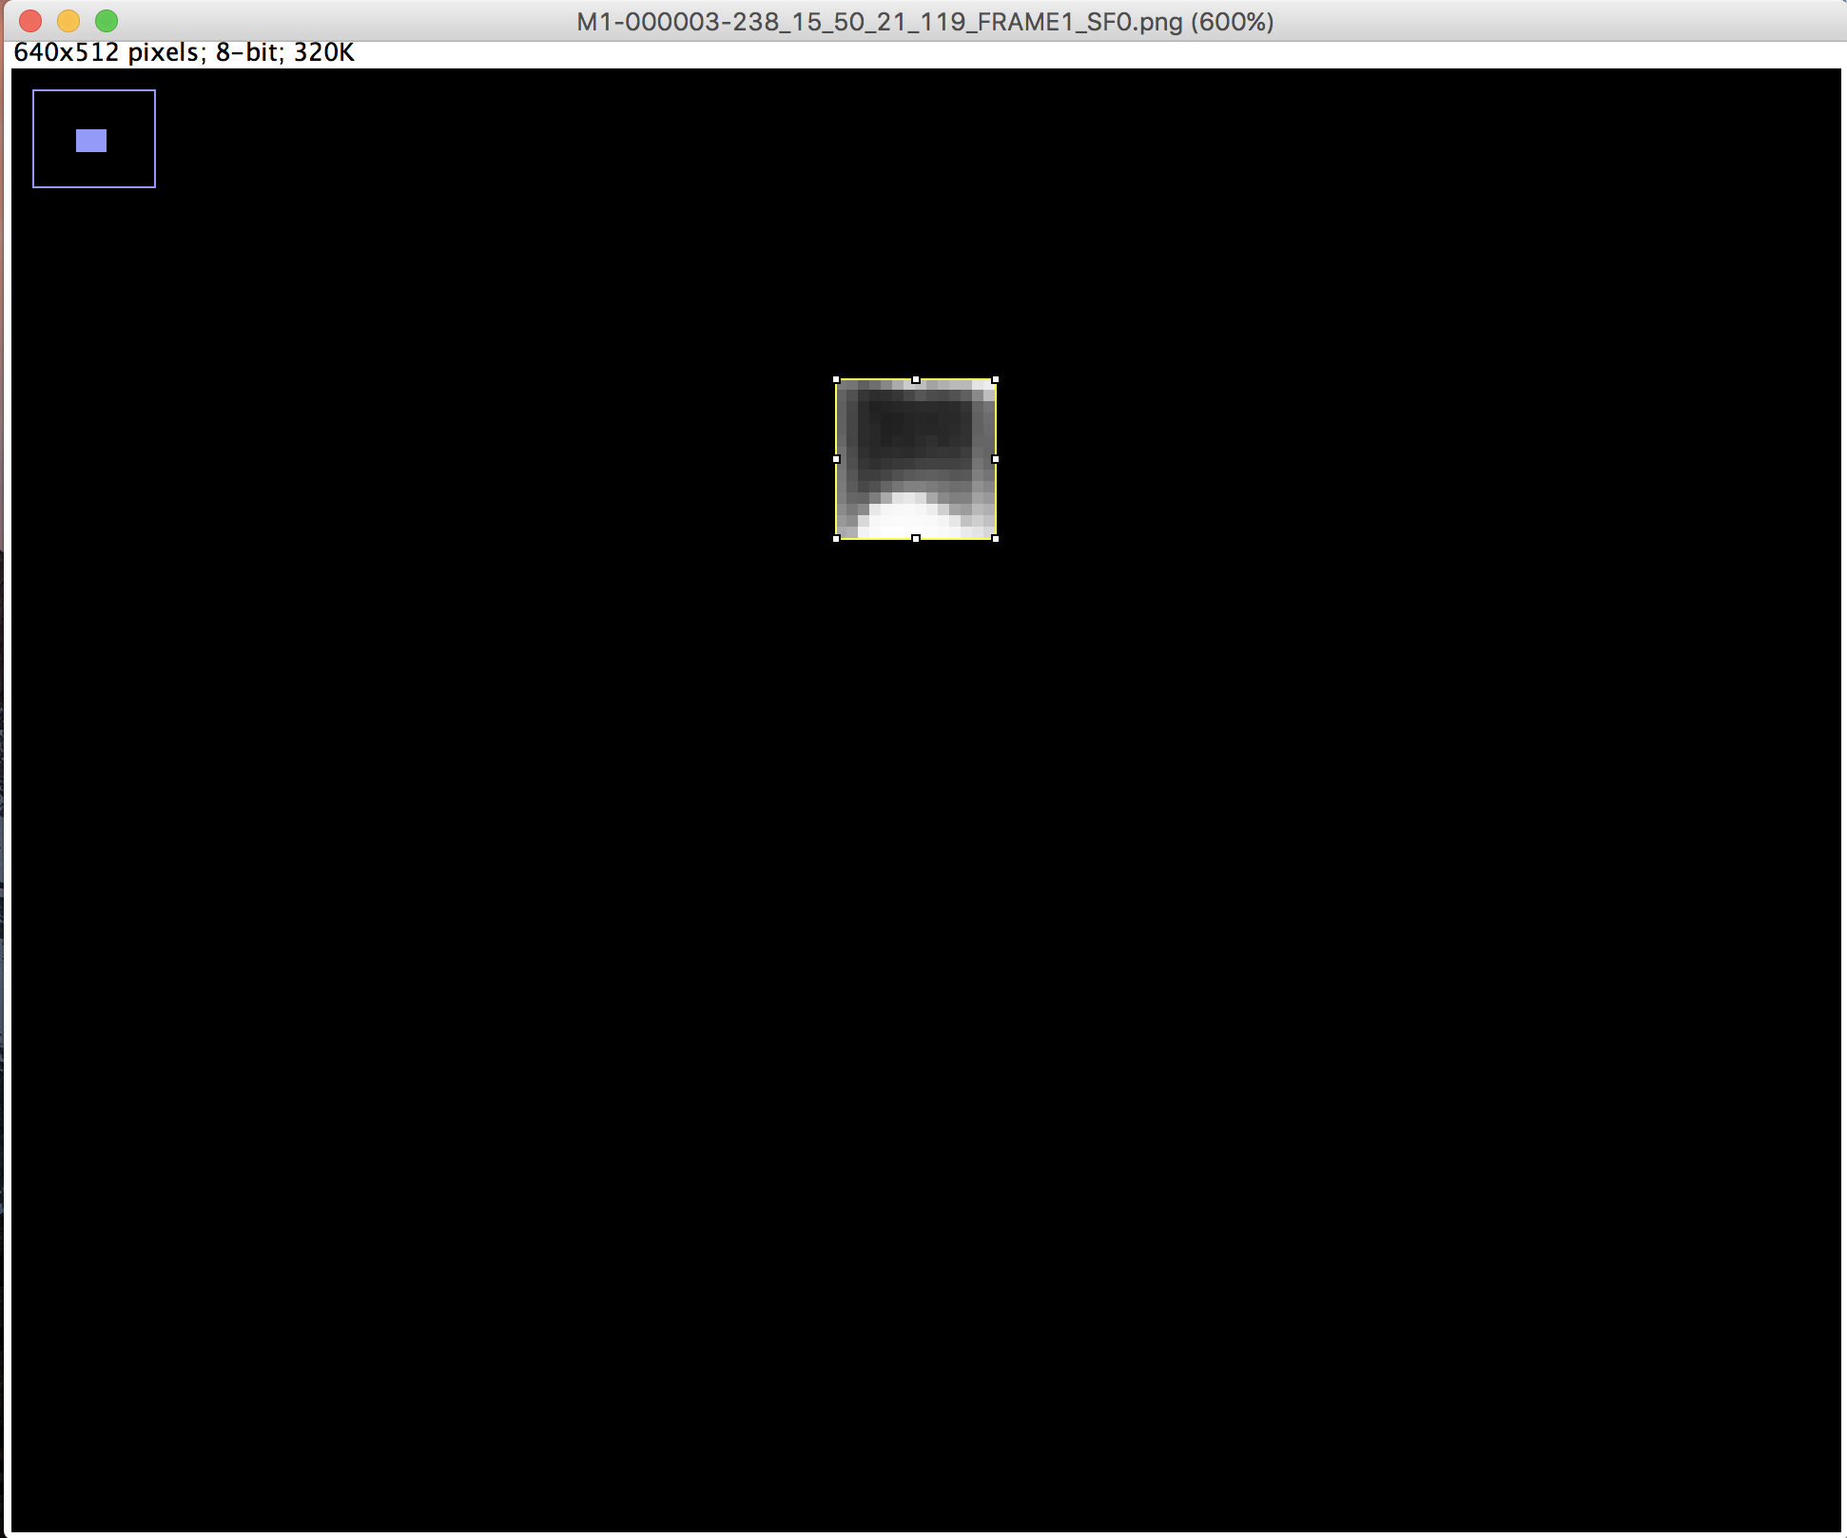

Apply threshold to remove background or select only target (Both methods detailed above)

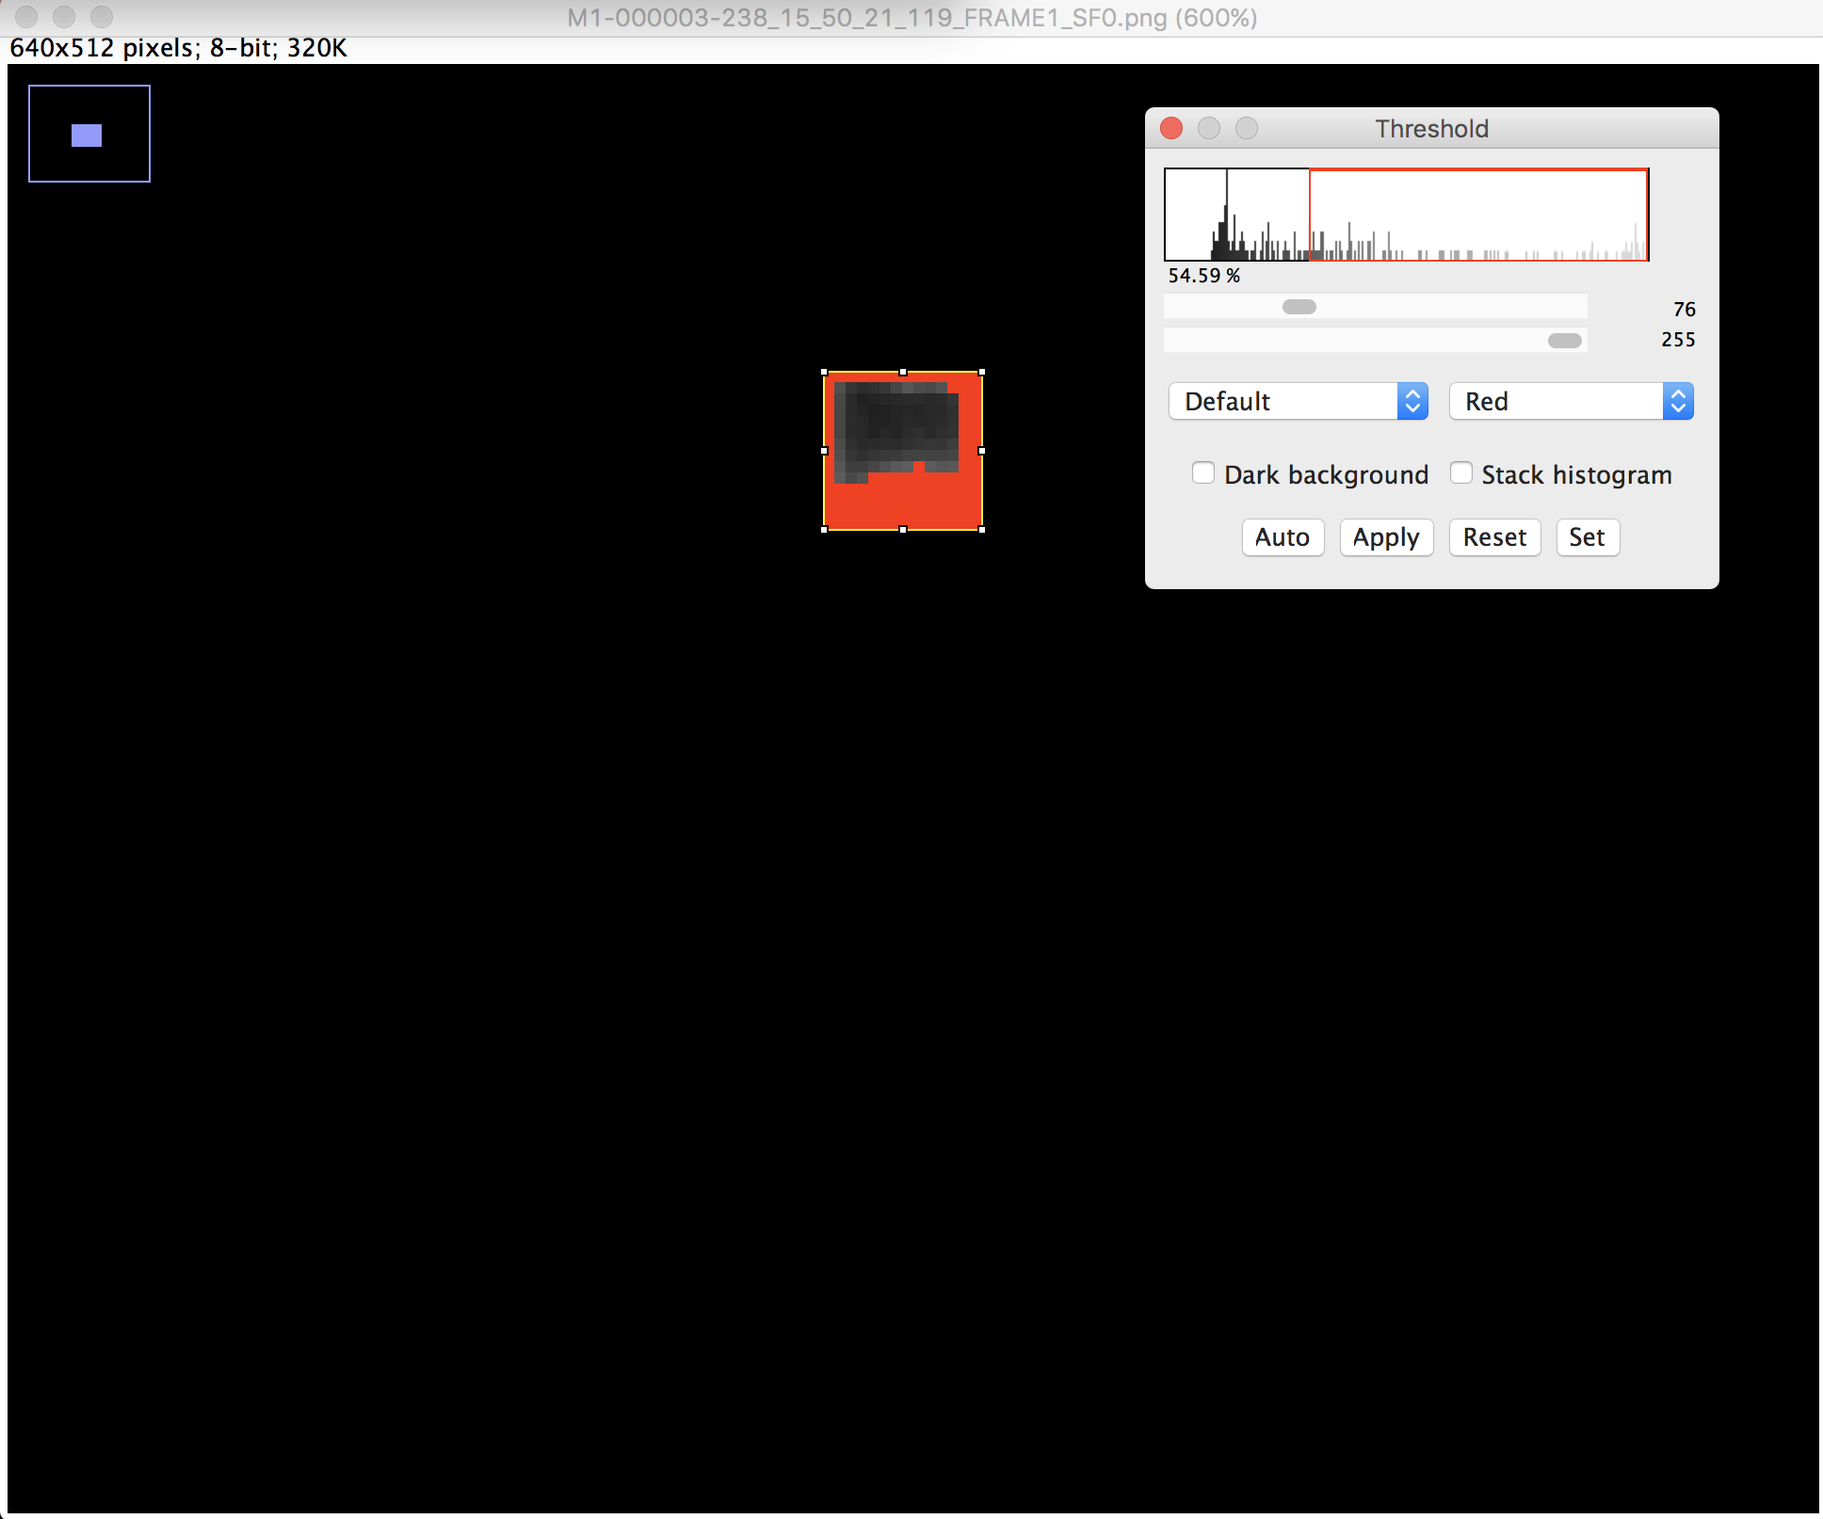

Select Apply in the threshold window, then use the Wand tool to select only the background segmentation and Add to ROI Manager. Rename it to BG-1, etc.

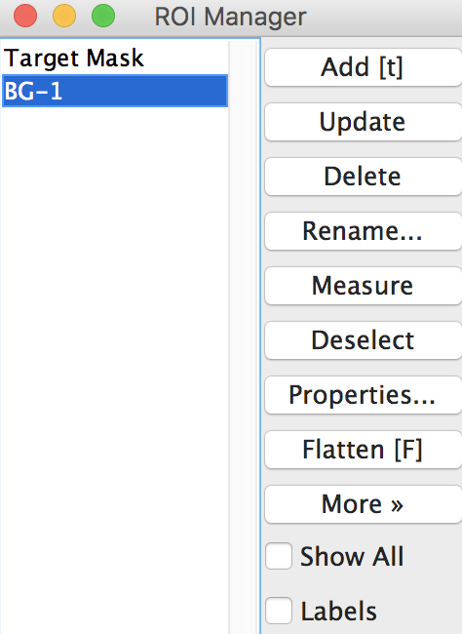

Close the Image window, and open a new one through File -> Open Recent. Select both ‘Target Mask’ and ‘BG-1’ in the ROI Manager window and Select More -> XOR

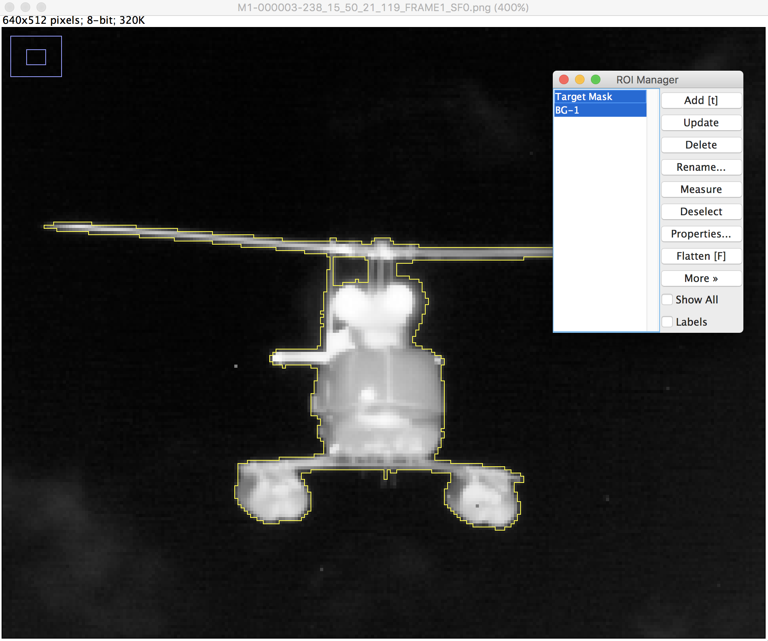

Add the current outline to the ROI Manager and rename it to ‘Refined Target-1’

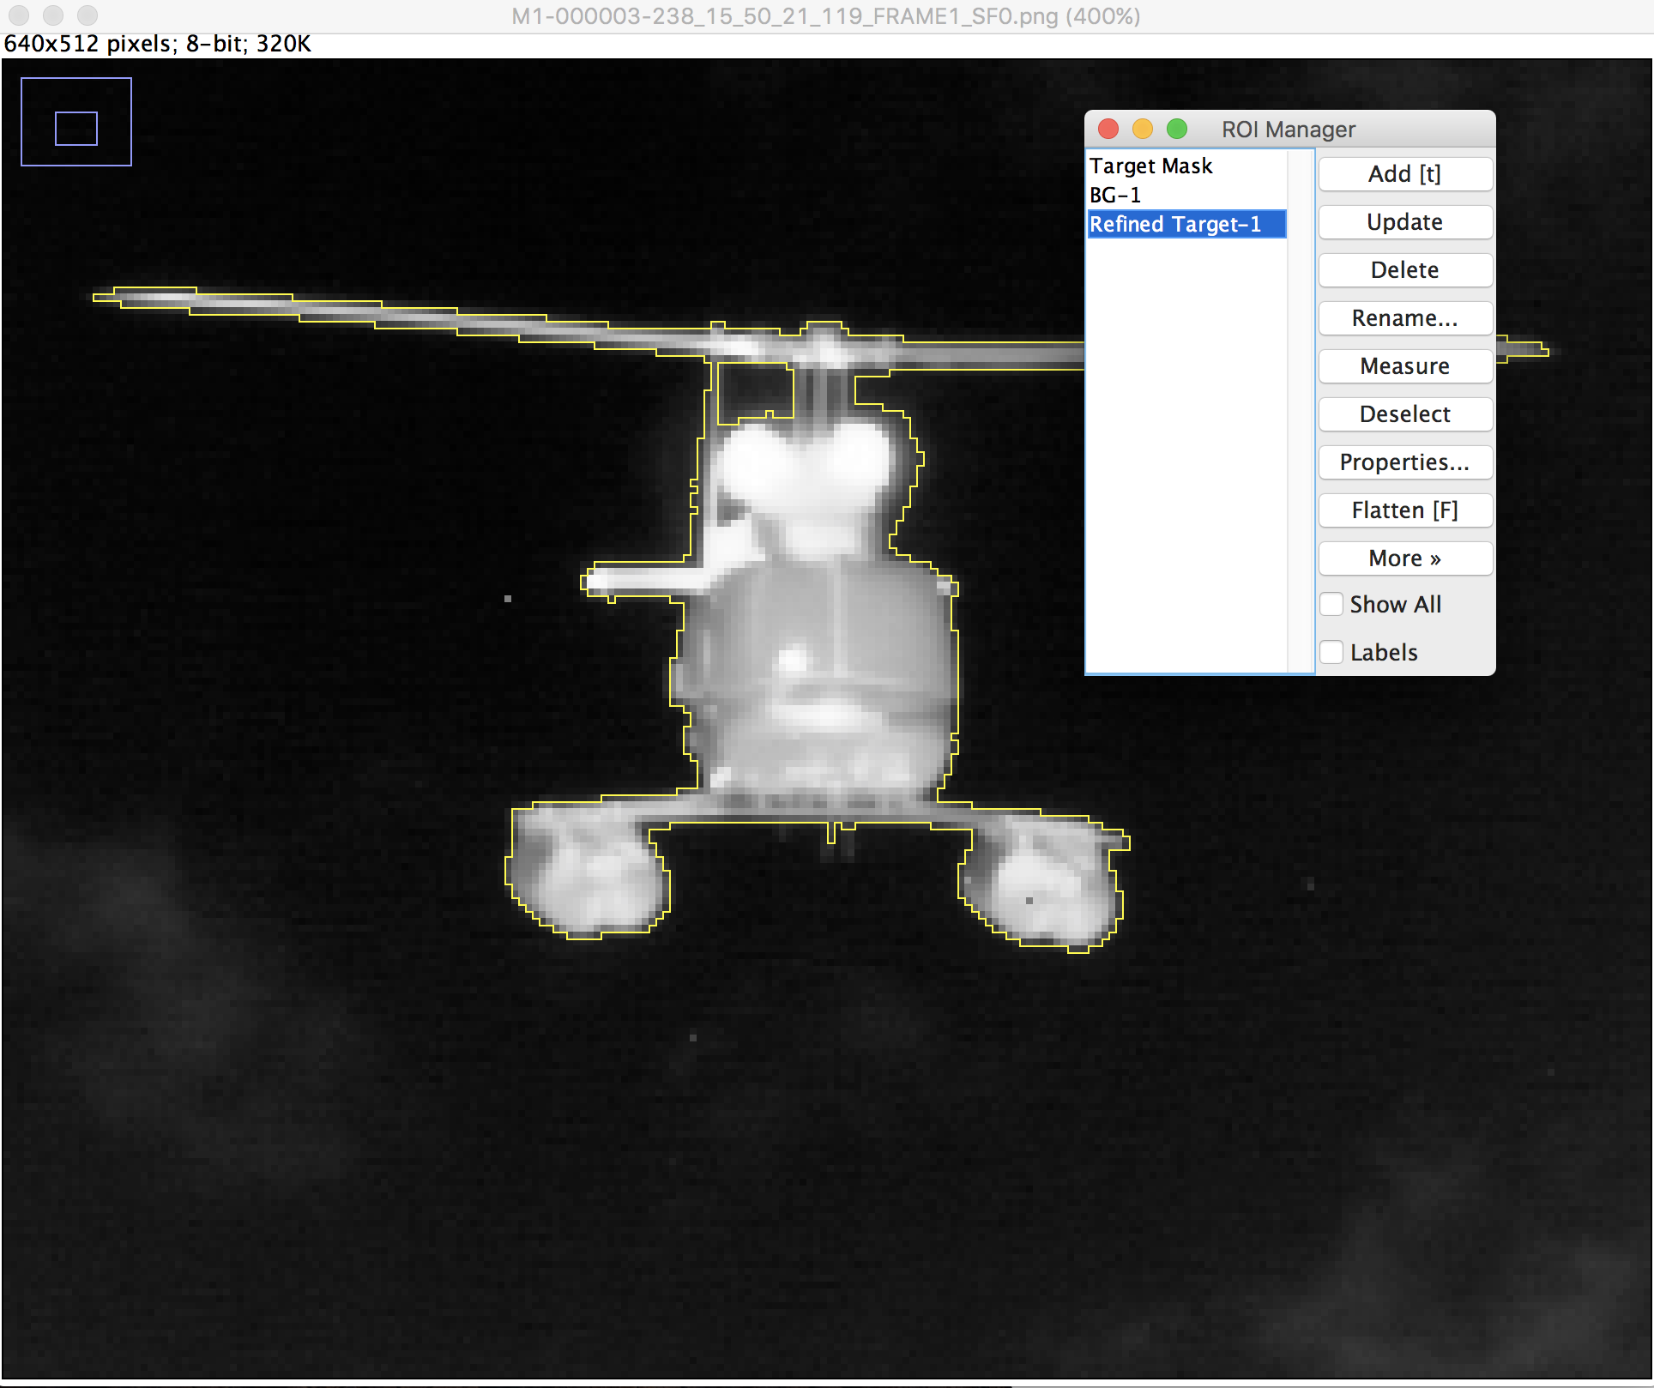

Repeat this process for the other features of the object (rotor spokes, small features, etc) and use XOR, AND, OR operations to combine the outlines.

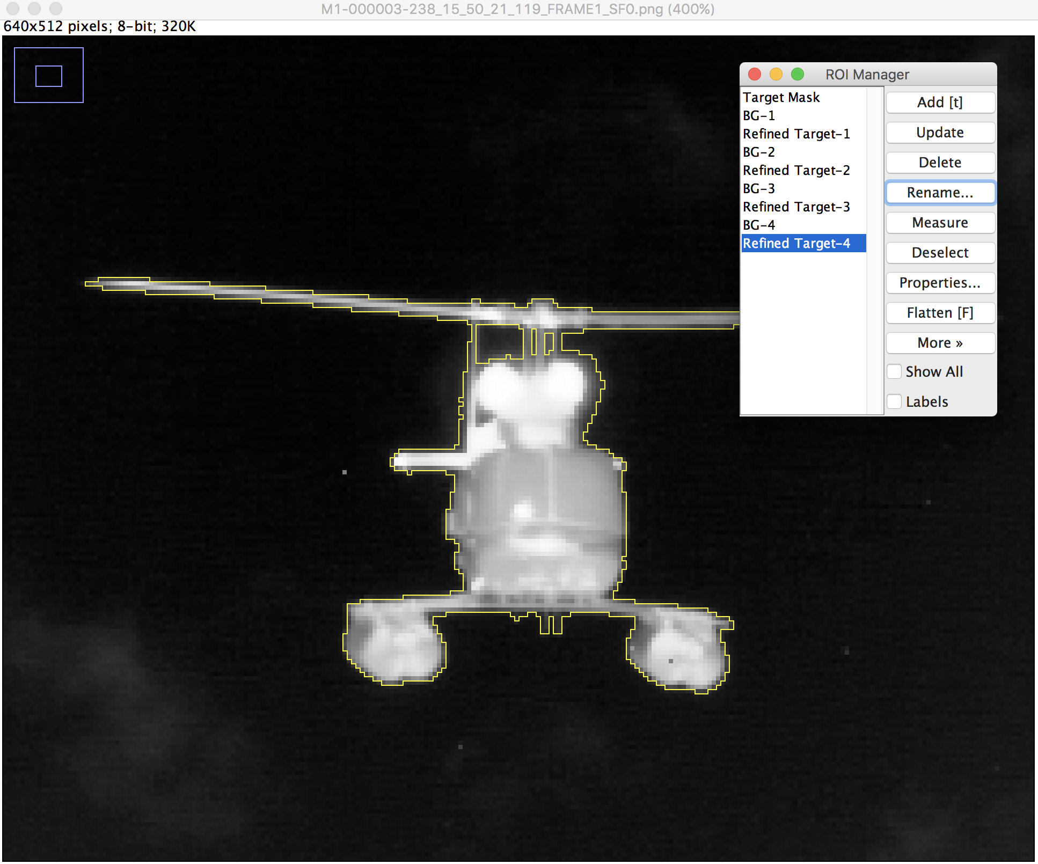

Navigate to Edit -> Selection -> Create Mask, and then Edit -> Invert

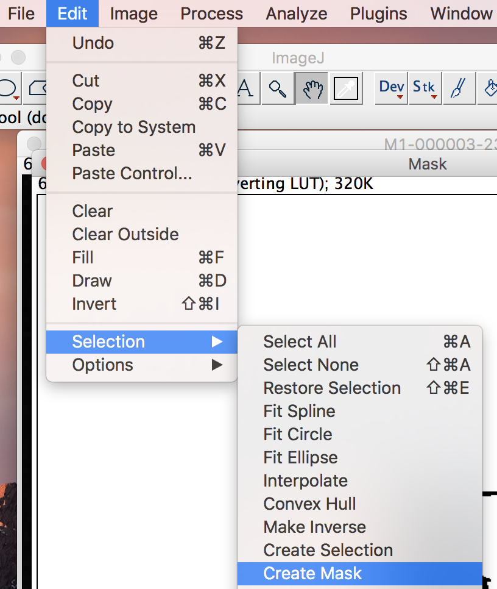

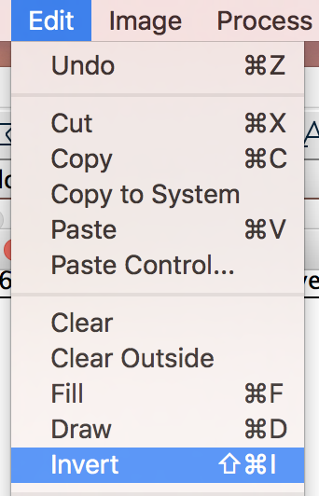

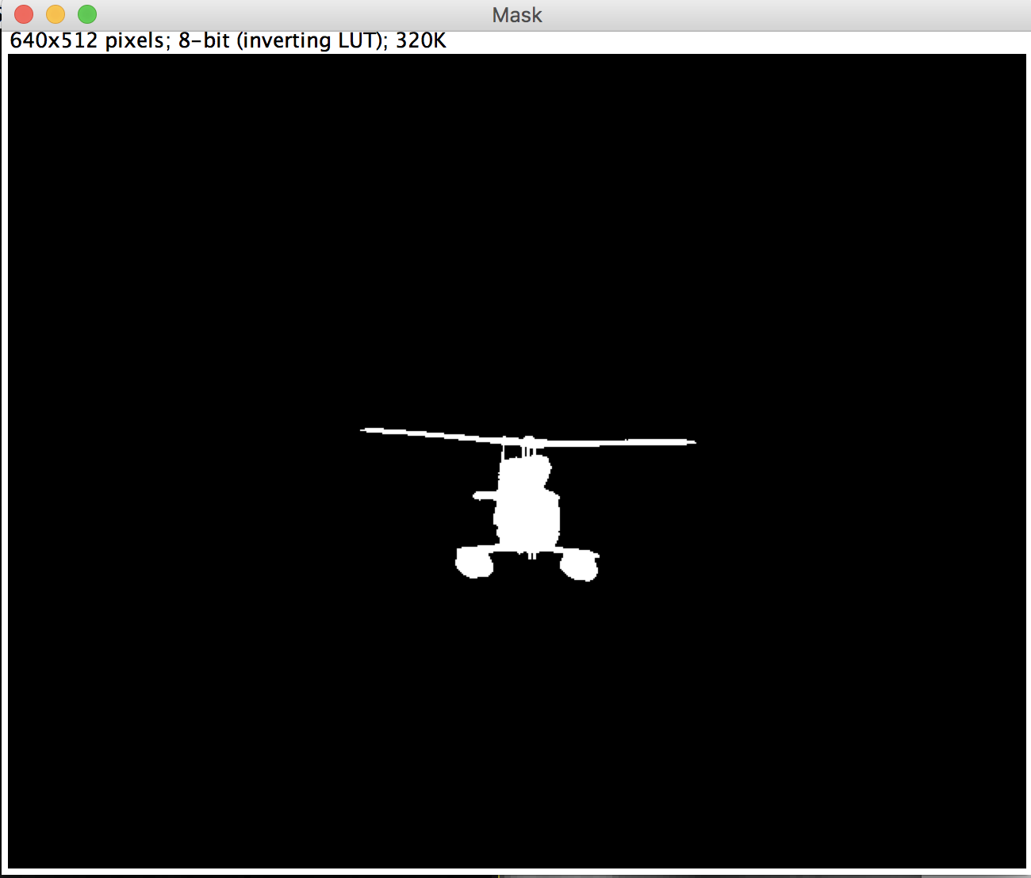

Navigate to File -> Save As -> PNG and save the final mask png with the correct label

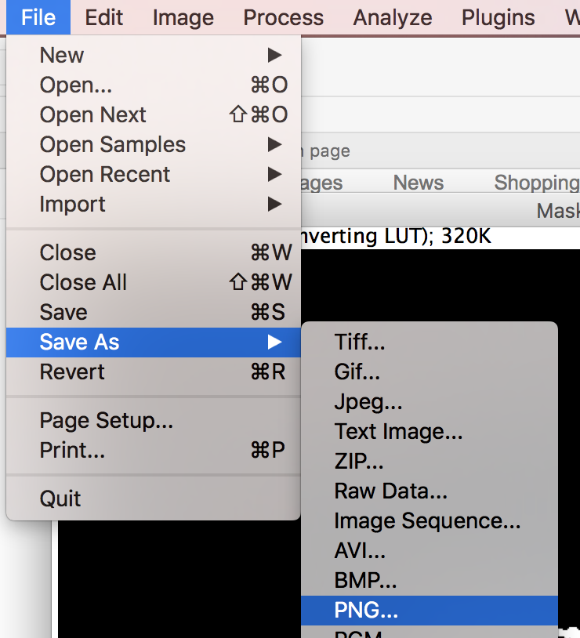

Navigate to the ROI Manager window and select all ROIs, then navigate to More -> Save and save the entire set of the ROIs with the correct label

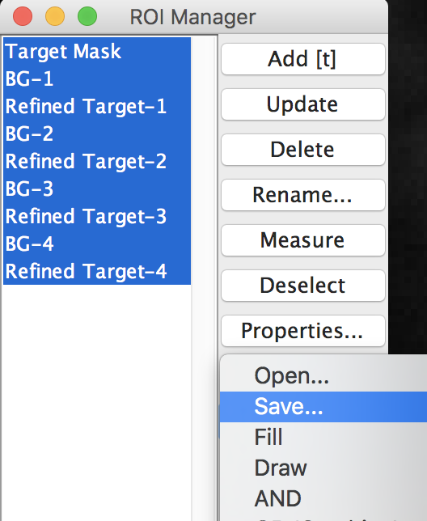

The mask PNG and the corresponding ROIs have been saved and the GT for the current frame is complete

